**Contents**

**Week 1**

1. **My learning**

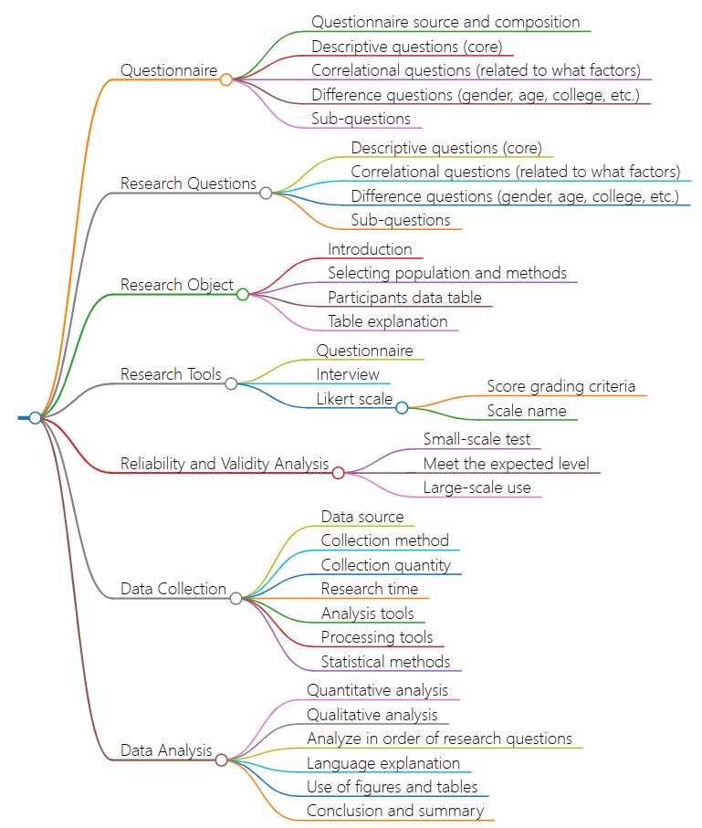

1. **Learning outcomes**

* Master the basic elements and processes of data collection and analysis, and improve the efficiency and accuracy of data collection and analysis; Better formulate questionnaires and research questions in future scientific research work;
* Understand the influence of data source, collection method, quantity and time, which has great reference for future research design; Pay more attention to scientific and practical aspects of the selection, data collection and processing of research objects;
* Know to explain the research results in scientific and objective language, and use charts to visually represent them. Use scientific statistical methods and data analysis tools when conducting research to enhance the reliability and practicality of research results.

1. **My behavior and attitude**

**4．Improvement**